Dr.Ala Ali Abuthawabeh Database Programming   
  
Project : RestaurantManagementSystem  
  
Students Work:   
  
1.Mahmoud Hussein 201910622  
  
2.Abdulrahman Yosif 202010599

* 1. The restaurant sector encounters difficulties in effectively handling orders, monitoring menu items, and guaranteeing a smooth client experience. Conventional manual systems can result in mistakes, hold-ups, and trouble adjusting to evolving needs. A contemporary restaurant management system is necessary to solve these problems.   
       
       
     Project Scope: By offering an integrated platform for managing menu items, processing orders, and improving overall efficiency, the suggested Restaurant Management System seeks to optimize a restaurant's operations. The system will have the following essential components:

1. Menu Management:

* Dynamic creation, update, and deletion of menu items.
* Categorization of items into appetizers, main courses, salads, drinks, desserts, etc.
* Inclusion of prices and detailed descriptions for each item.

2. Order Processing:

* Ability to add, modify, or remove items from a customer's order.
* Real-time updates on the status of orders (e.g., preparing, ready for delivery).
* Integration with a point-of-sale (POS) system for seamless transactions.

3. Shopping Cart:

* A user-friendly shopping cart for customers to review and edit their orders.
* Display of the total price and any applied discounts.

4. Discounts and Promotions:

* Application of discounts based on predefined rules (e.g., order total, promotional events).
* Handling of promotional offers and special discounts.

5. User Authentication and Authorization:

* Different user roles (customer, staff, manager, admin) with varying levels of access.
* Secure authentication to ensure data privacy.

By addressing these aspects, the Restaurant Management System aims to enhance the overall dining experience for customers, improve operational efficiency, and provide valuable insights for business decision-making. The system's scope is focused on the internal processes of the restaurant, and future enhancements may include external integrations and additional functionalities based on business needs.

* 1. Project Plan and Schedule

1. Project Initiation (Week 1-2):

* Define project scope, objectives, and deliverables.

2. Requirements Gathering and Analysis (Week 3-4):

* Analyze existing systems and identify integration points.
* Create use cases, user stories, and wireframes.

3. System Design (Week 5-7):

* Develop a detailed system architecture.
* Design the database schema.
* Create mockups and prototypes for the user interface.

4. Development (Week 8-14):

* Implement the backend logic and database functionality.
* Develop the frontend interfaces for different user roles.
* Implement user authentication and authorization.

5. Testing (Week 15-17):

* Conduct unit testing for individual components.
* Perform integration testing to ensure seamless communication.

6. Deployment (Week 18-19):

* Prepare for the deployment of the system.
* Monitor system performance and address issues.

7. Project Closure (Week 22):

* Conduct a project review and evaluation.
* Obtain feedback from stakeholders.
* Officially close the project.

Gantt Chart of project:

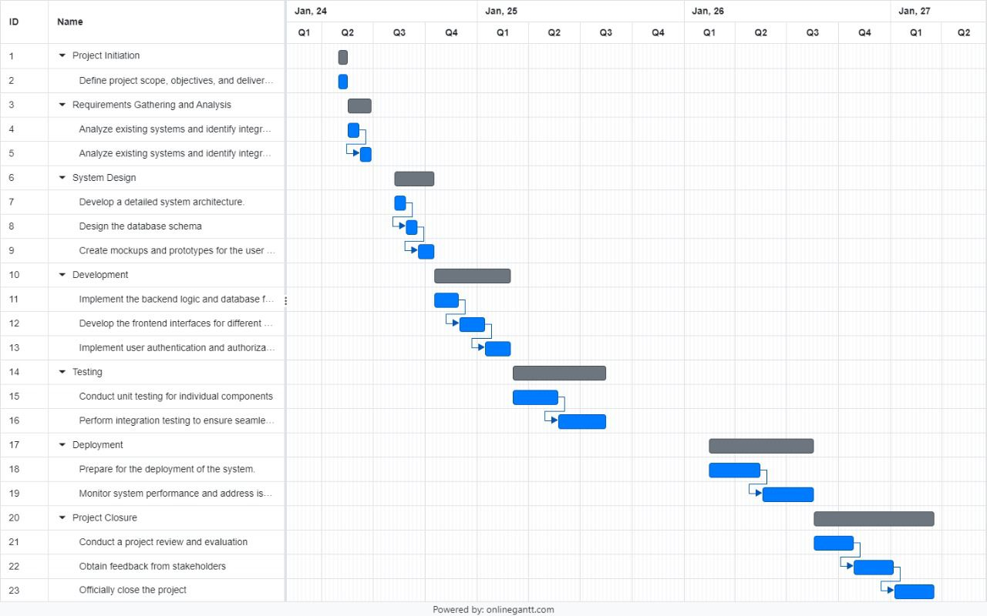

Use case :

ER-Diagram:

Interface :

